6) Write a C program to find Fibonacci series using Recursion

PROGRAM:

#include <stdio.h>

int fibonacci(int n) {

if (n <= 1)

return n;

return fibonacci(n - 1) + fibonacci(n - 2);

}

int main() {

int n, i;

printf("Enter the number of terms: ");

scanf("%d", &n);

printf("Fibonacci Series: ");

for (i = 0; i < n; i++) {

printf("%d ", fibonacci(i));

}

return 0;

}

INPUT:

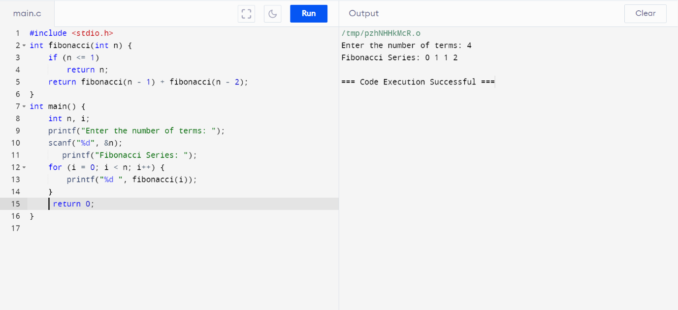

OUTPUT:

